# Lab 3. Simulation components of dynamic systems

**Name: Zhu Chenhao**

**ITMO ID: 375462**

## Specialization: Automation

|  |  |  |  |  |  |  |  |  |
| --- | --- | --- | --- | --- | --- | --- | --- | --- |
| **Variant** | **U** | **Ψ** | **R** | **L** | **J_M** | **J_L** | **b** | **k** |
| 94 | 24 | 0.229183 | 0.35 | 0.00035 | 0.001501 | 0.004502 | 0.06 | 1700 |

**1. Simscape model of DC-motor.**

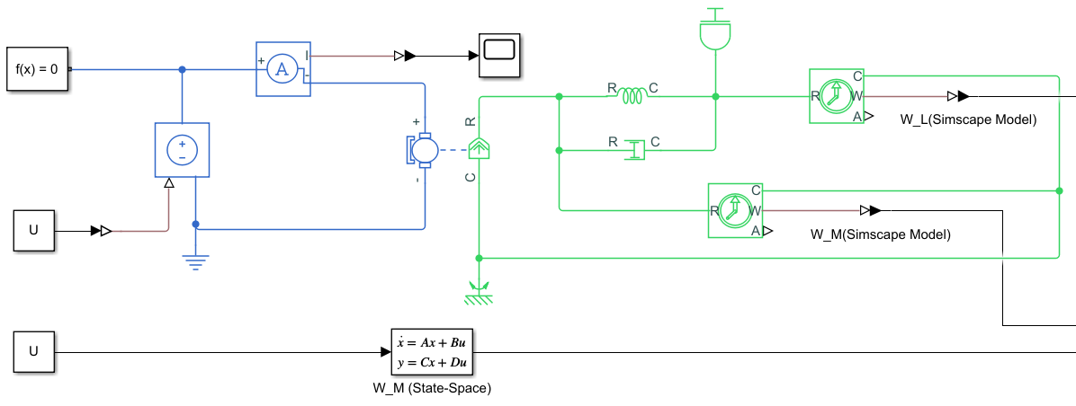

**Figure 1.** Equivalent circuit.

**2. Block diagram model of DC-motor.**

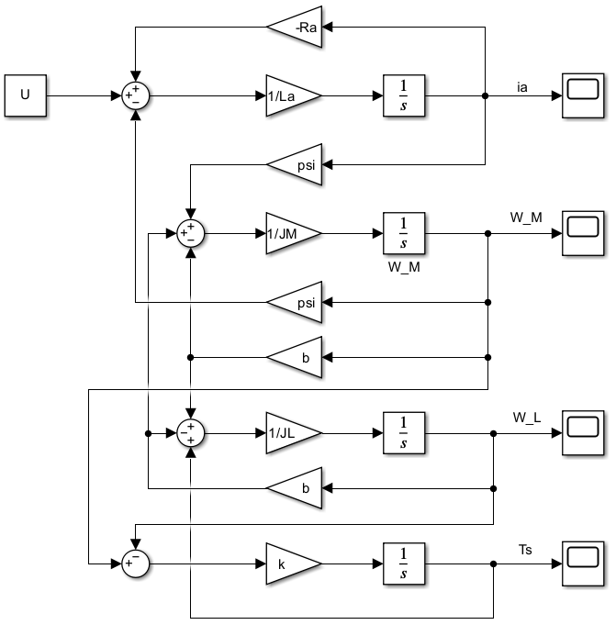

**Figure 2.** Simulation circuit.

**2. Transfer functions of DC-motor.**



**3. State-space model.**

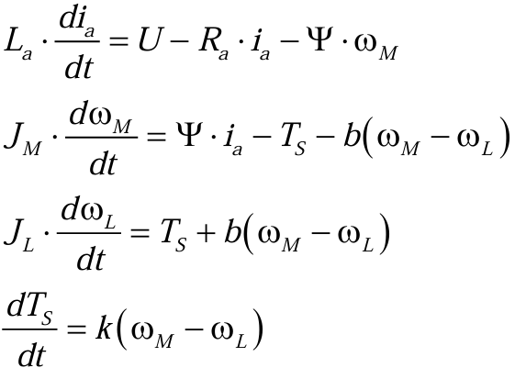

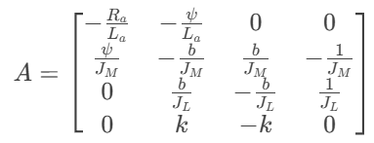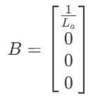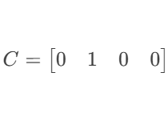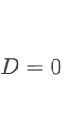

**5. Simulation results for 2 cases**

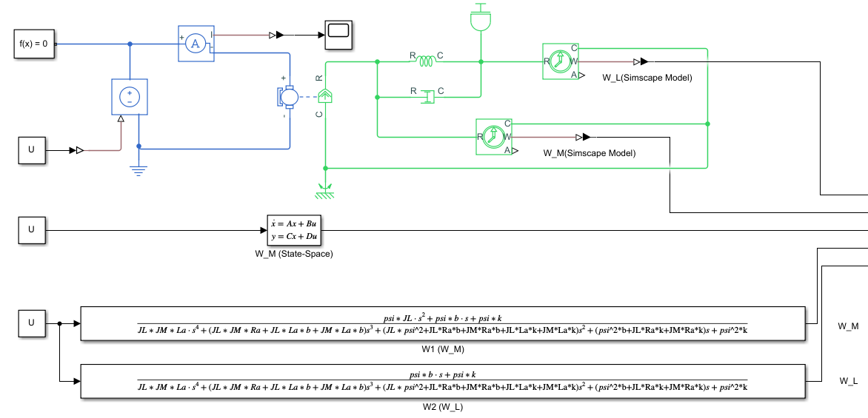

**Figure 3.** Three models

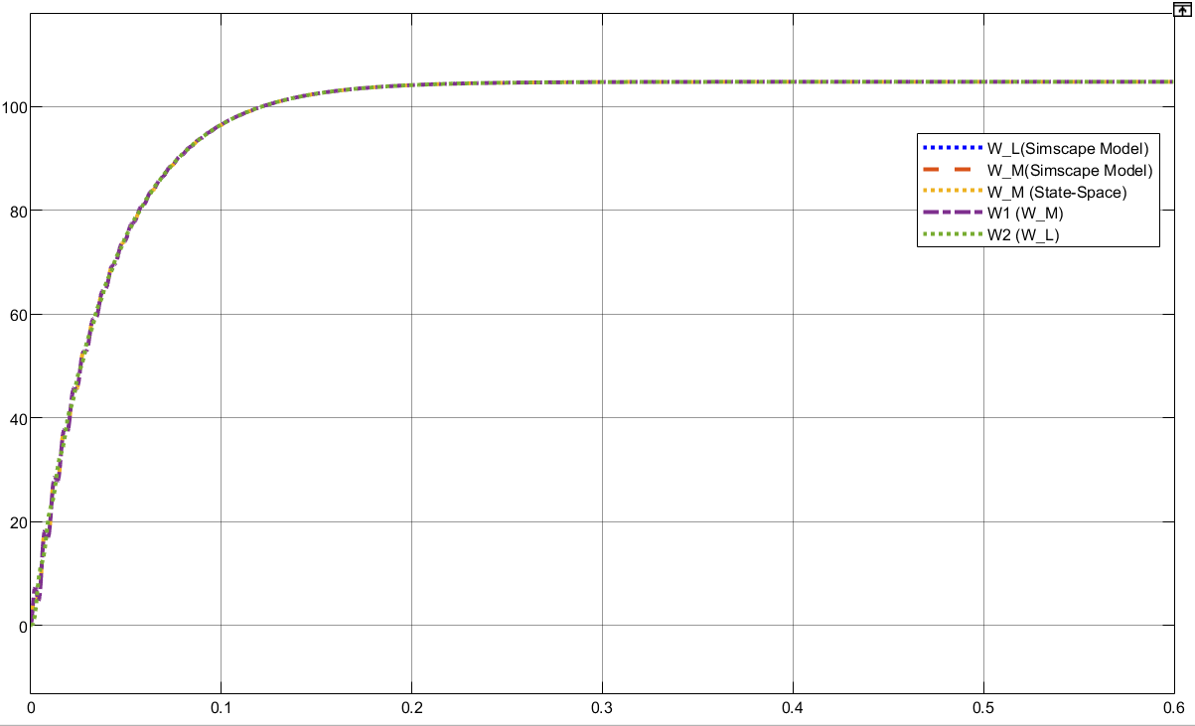

**Figure 4.** Simulation results of different models.

**6. Calculation of transient response.**

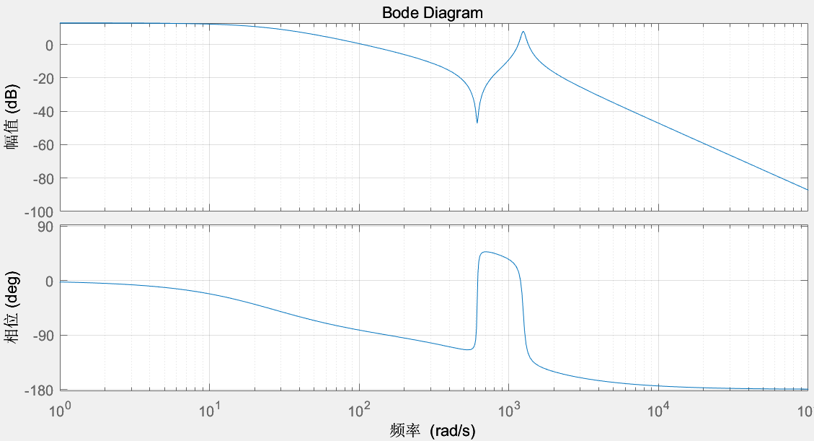

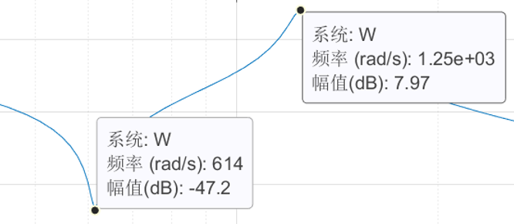

**Figure 5.** Bode plots of W1

Resonant frequency of the mechanical subsystem: **614 (rad/s), 1250 (rad/s)**

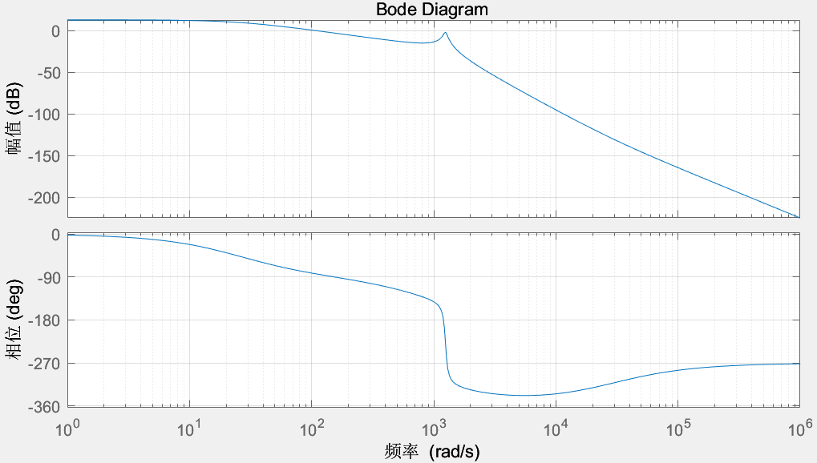

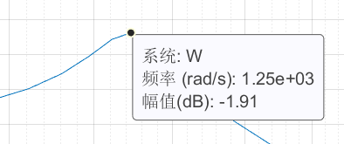

**Figure 6.** Bode plots of W2

Resonant frequency of the mechanical subsystem: **1250 (rad/s)**

**7. Multi-harmonic input signal.**

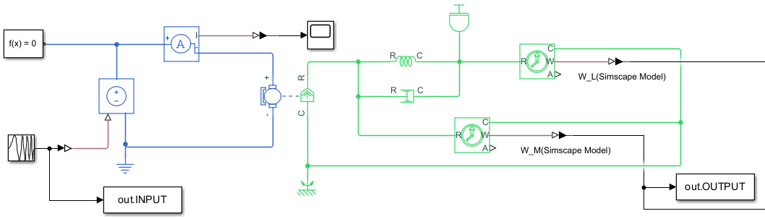

**Figure 7.** Equivalent circuit.

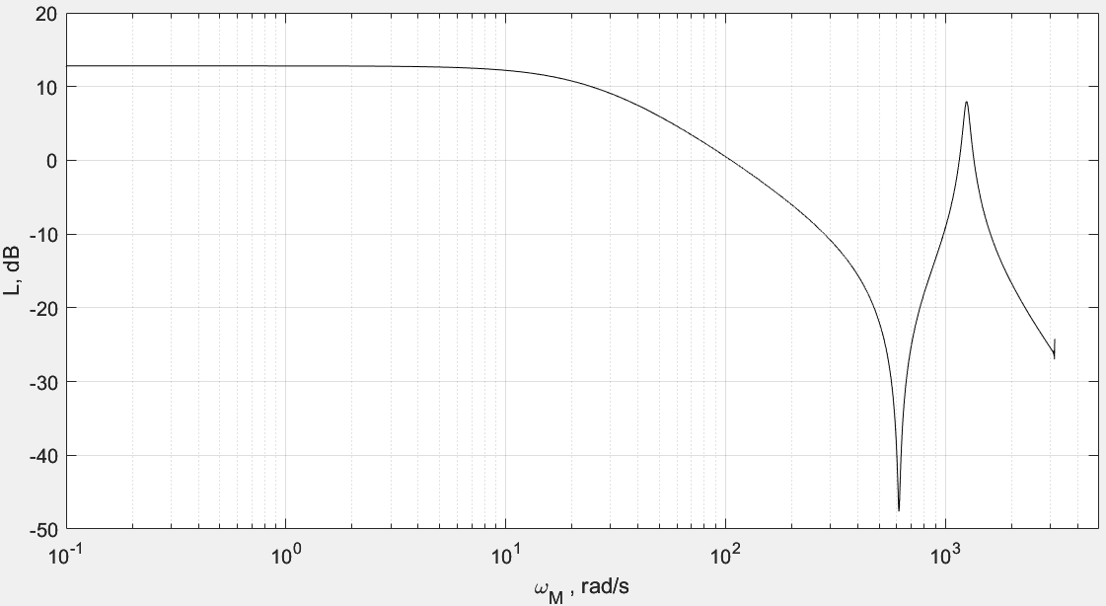 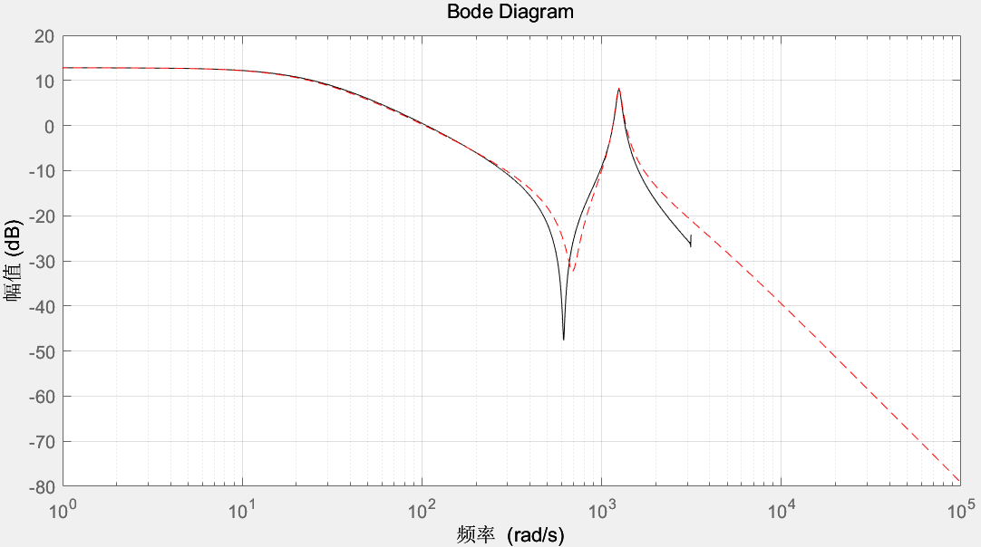

**Figure 8.** Frequency response.

*It seems to have a little shift for the first Resonant frequency compared to the original one. Maybe there is some problem in recognization in matlab.*

**Conclusions:**

1. Dynamic Models: The DC motor with a two-mass load and elastic joints was successfully modeled using Simscape, block diagrams, transfer functions, and state-space representations. Each model provided unique insights into the system's behavior.
2. Bode Plots & Resonant Frequencies: Bode plots were constructed, revealing resonant frequencies at 614 rad/s and 1250 rad/s, critical for stability analysis. The frequency response showed good agreement between models.
3. Simulation Results: Simulations validated the models, showing consistent results across Simscape, block diagrams, and state-space representations. Transient responses highlighted underdamped and overdamped behaviors.
4. Experimental Validation: The experimentally estimated frequency response and transfer function matched well with the original model, confirming the accuracy of the experimental approach.
5. Model Comparison: All models (Simscape, block diagram, transfer function, state-space) produced consistent results, reinforcing their reliability. The experimental transfer function slightly deviated but overall aligned with the original.